**COSC2543 Mobile Application Development**

**Assignment 2**

**Android Application Proposal**

|  |  |
| --- | --- |
| Semester | 2012B_______________________________________ |
| Student 1 (ID & Name) | 3342135 – Vuong Do Thanh Huy_________ |
| Student 2 (ID & Name) | 3342137 – Phan Quang Hung_____________ |
| Student 3 (ID & Name) | ______________________________________________ |

* **Executive Summary**

It is a Apps Market. It display apps currently in the market and allow users to choose and install them. It also manages all apps installed by it, allowing users to update to newer version when available.

* **Application requirements**

A basic Android phone should be adequate to run this app: HVGA, CPU 500MHz+, RAM 512MB+, Internet connection,

* **Application’s functionalities.**

Function A: Display app list

It will connect to the database, query the list of all current apps in service, and display it on the screen. Each app will be display with the information: Avatar, short description, Star and a button to install/remove/update.

Function B: Install app

A button is placed next to each app info widget, allowing user to tap on it. It will download the desired .apk file and trigger it.

Function C: Update app

Each time user starts this app market, it will check for update for all apps in its management (i.e. those installed by this market). If any update is available, user will receive a notification. User can choose to update or ignore the message.

**…**

* **Screen Design and Information Flow using** <http://www.droiddraw.org/> **or paper’s sketch.**

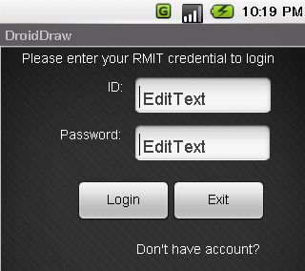

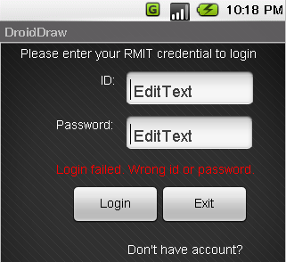

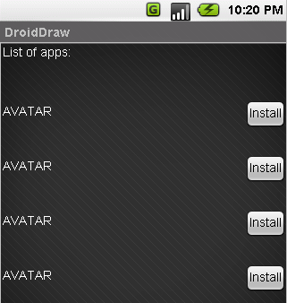

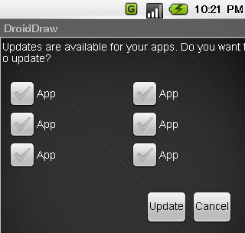

**Applied Areas**

* + Google Map API

None

* + Music Player service

None

* + Location API

None

* + Content Providers

This app connects to a database, through PHP script to get information.

* + Widgets

This app use types of widget.

* + SQLite DB

This app store temporary data in local database to speed up performance.

* + Network Services

This app makes HTTP GET requests and retrieves information from server.

* + Telephone handling

None

* + Search Manager

None

*PS: This proposal includes 2 copies: 1 for student, 1 for lecturer*

Student Signature Lecturer Signature